This is the code that runs in the *server.php* file being hosted in the WSL terminal. What the code does is receives HTTP POST data and logs it on the local machine for analysis. Log files are formatted as follows:

**File Name:**

~/<server folder>/<username>.txt

**File Contents:**

[dd-mm-yyyy hh:mm]

Data to be analyzed

#############################

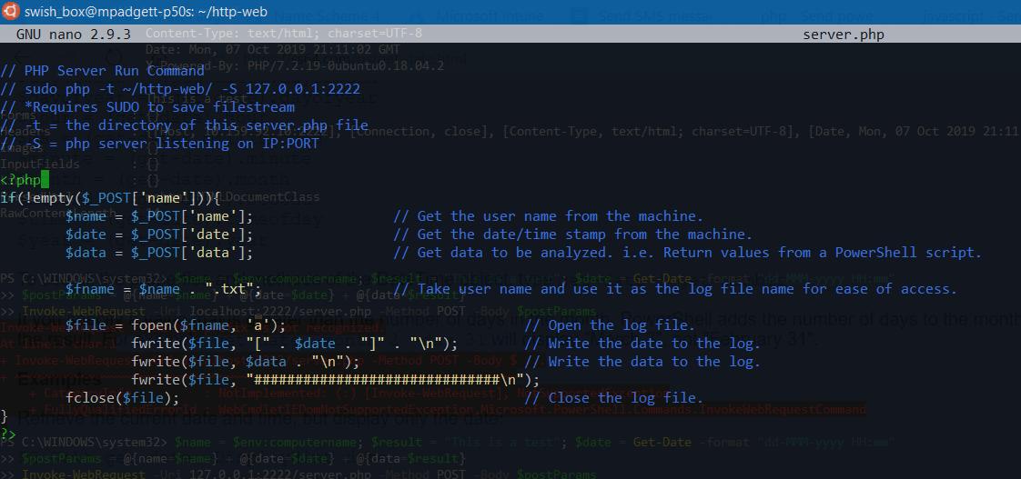

*Server.php* resides within the folder that is going to be used as the main directory for PHP.

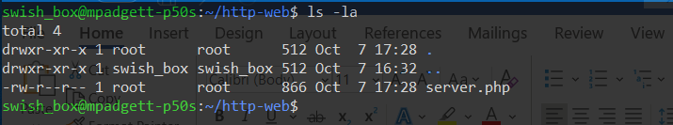

*-S* command is issued within WSL terminal, which instructs PHP to listen on port 2222 from TCP/IP 127.0.0.1. The *-t* command tells PHP that the directory *~/http-web/* is the main resource directory.

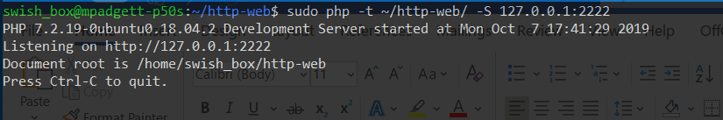

The function *Send-Data($DataToSend) {}* gathers the user’s name, the current date, and the data to be sent. This is sent to the PHP server via the HTTP POST method.

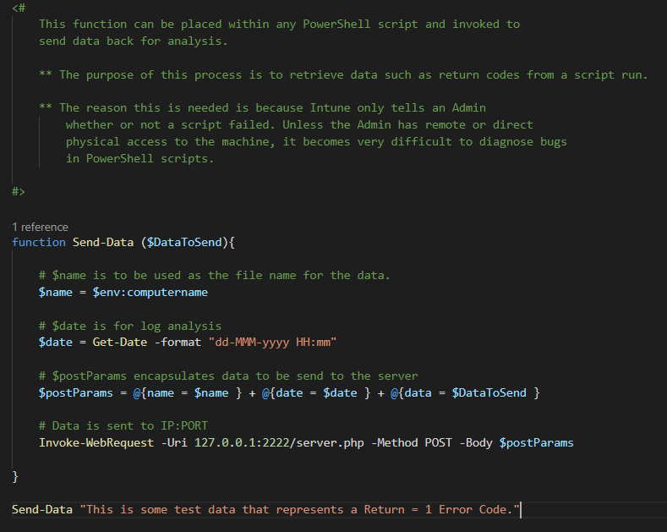

The PHP server in WSL registers code 200, which refers to a successful connection from the PowerShell script.



A check of the directory in WSL now shows that the file *MPADGETT-P50S.txt* has been created.

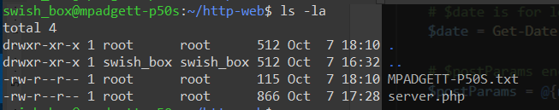

Opening the file *MPADGETT-P50S.txt* shows the data that has been sent.

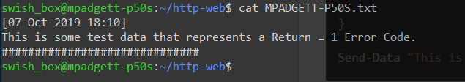

Sending more data to the PHP server is logged by the server.

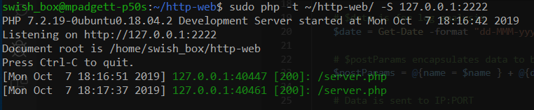

Opening the *MPADGETT-P50S.txt* log shows the new data appended to the log.

